**BUG REPORT**

**Bug 1: No Internet Connection Message Despite Active Connection**

**Title**: "No Internet Connection" message displayed on home screen despite active and stable internet connection.

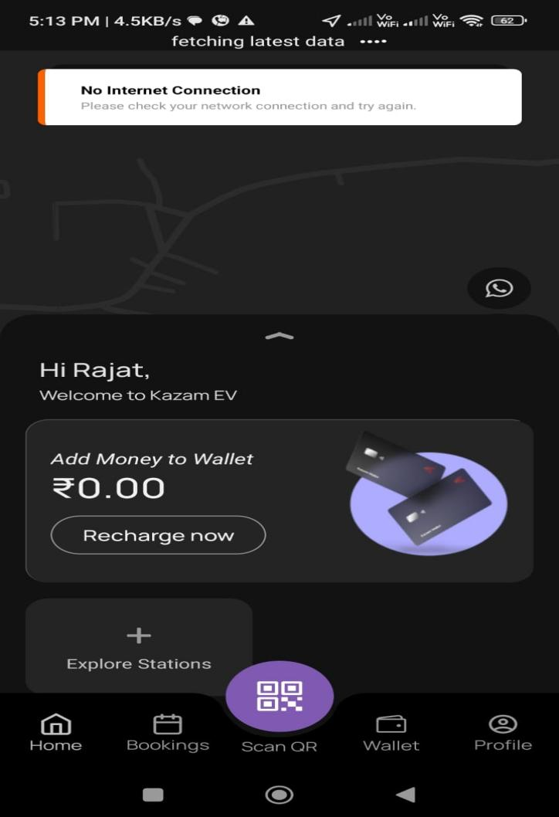

****Description****: After successfully logging into the Kazam EV app, a popup message stating **"No Internet Connection"** is displayed on the home screen. However, the device was connected to a high-speed Wi-Fi network, and all other applications were functioning normally, confirming an active internet connection. This erroneous popup causes confusion for the user, potentially blocking further app functionality.

### ****Bug 2: Unable to Update Mobile Number in Profile****

****Title****: Mobile number field not editable during profile update; no error message displayed.

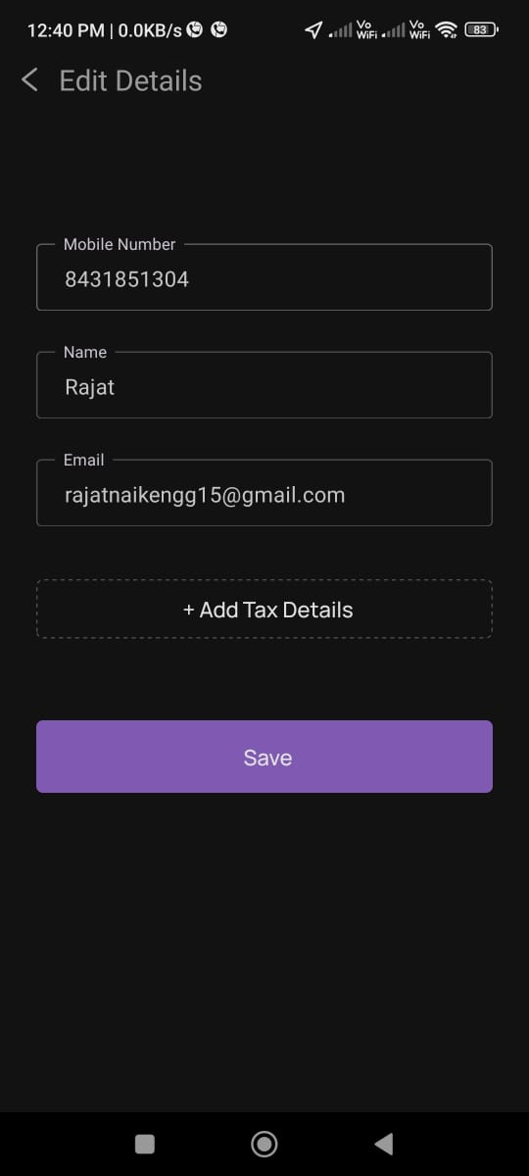

****Description****: When attempting to update the profile information under the Profile Tab, the **Mobile Number** field is non-clickable and uneditable. However, the **Name** and **Email** fields are editable and can be updated successfully. There is no message or notification explaining why the mobile number cannot be updated. If this field is intentionally restricted, the application should display an appropriate message, such as **"Mobile number cannot be updated"**.

**Bug 3: Error When Submitting Reviews on Charger**

****Title****: Error message displayed when submitting a review for chargers.

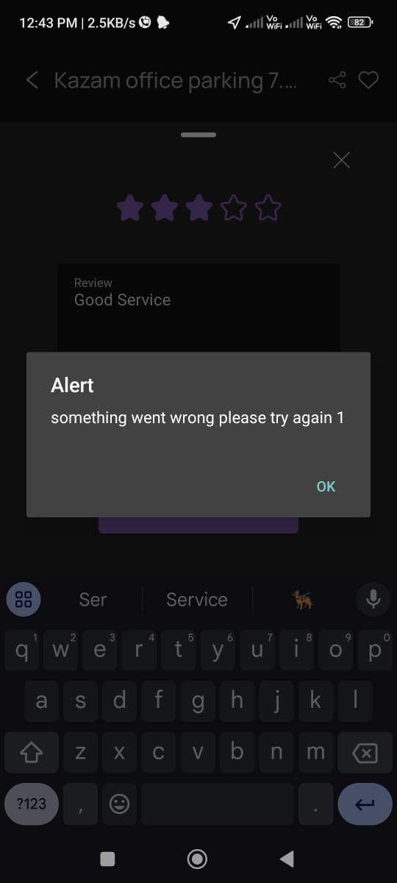

****Description****: Users encounter an error message ("something went wrong please try again 1") when attempting to submit a review and rating for a charger. This issue prevents the user from successfully submitting their feedback.

**Bug 4: Irrelevant Tax Details Accepted**

****Title****: Irrelevant tax details accepted in the profile update

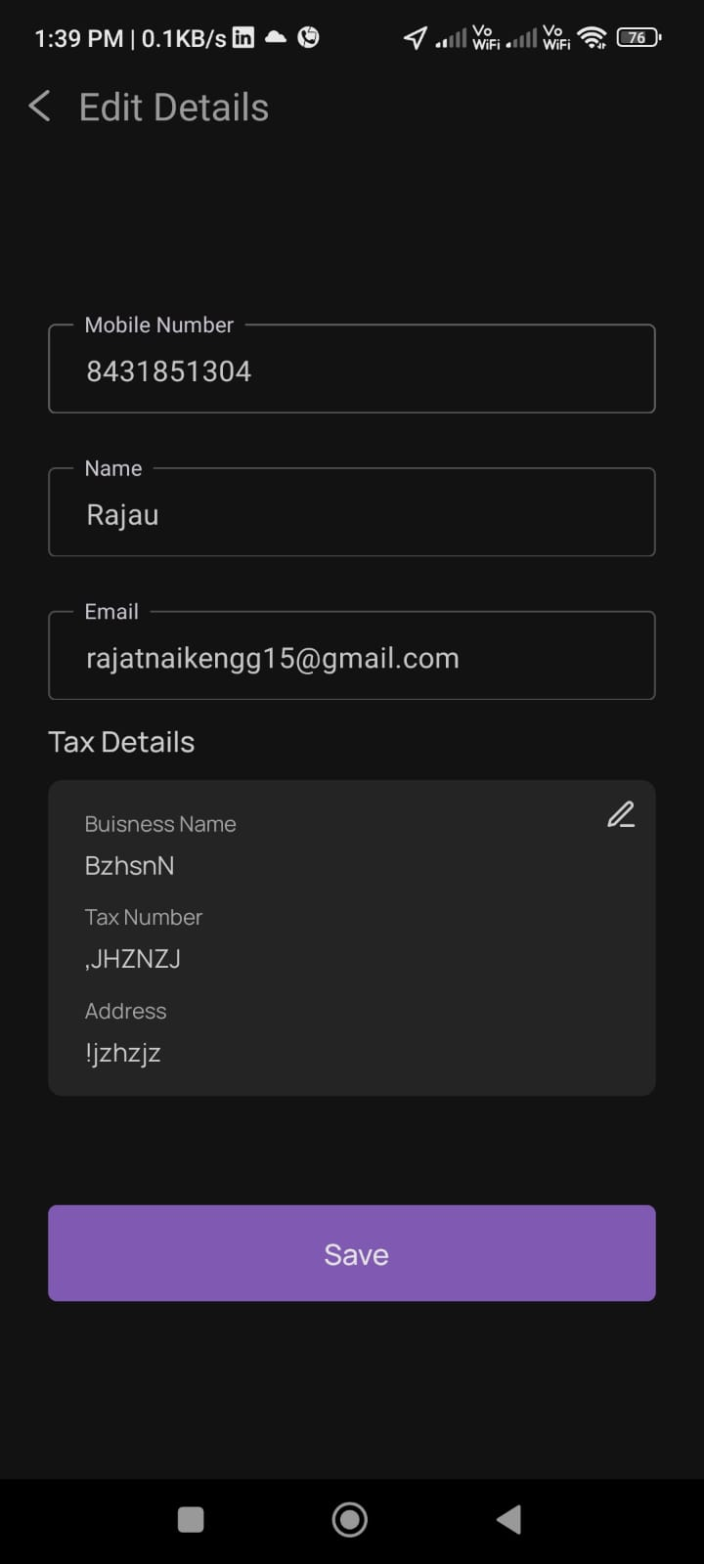

****Description****: The application allows users to input irrelevant or nonsensical details in the "Tax Details" section under the profile update. Fields such as "Business Name," "Tax Number," and "Address" accept any input without validation. This can result in invalid information being saved

### ****Bug 5: Missing Validation for Pincode in Tax Details****

****Title****: Missing validation for mandatory pincode in the address

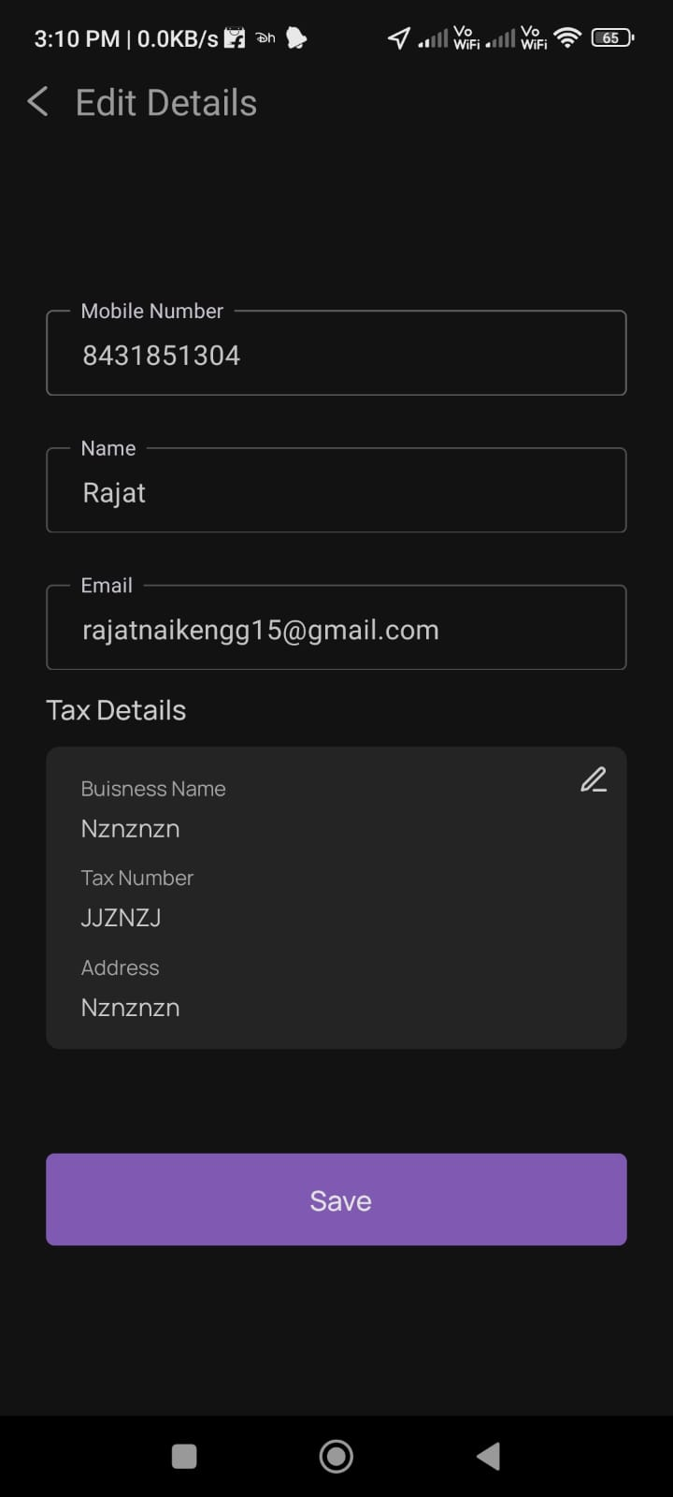

****Description****: When adding tax details such as "Business Name," "Tax Details," and "Address," the app mentions that the user should provide the pincode along with the full address. However, if the user omits the pincode and saves the address, the application still accepts the details without any error or warning. This behavior confuses users as to whether the pincode is a mandatory field or not. Additionally, no asterisk (*) is used to indicate mandatory fields, making it unclear which fields are required.